Practical No: 00
Aim: Introduction of NoSQL Databases Lab and Installation of NoSQL Databases.
Theory: NoSQL (Not Only SQL) refers to a category of modern, non-relational databases designed to store and manage large volumes of unstructured, semi-structured, and distributed data. Unlike traditional relational databases, NoSQL systems do not rely on fixed tables or schemas. They provide flexible data models, high scalability, and fast performance, making them ideal for big data, cloud applications, real-time analytics, and web-scale systems.

Types of NoSQL Databases

1. Document-based
- Stores data as JSON-like documents.
- Example: MongoDB, CouchDB

2. Key-Value Stores
- Simple key–value pairs.
- Example: Redis, DynamoDB

3. Column-Family Stores
- Uses columns and column families.
- Example: Cassandra, HBase

4. Graph Databases
- Data stored as nodes and relationships.
- Example: Neo4j, Amazon Neptune

Advantages of NoSQL Databases

1. Schema-less structure
- No fixed table schema is required.
- Documents/records can have different fields.
- Supports unstructured and semi-structured data.

2. High Scalability
- Supports horizontal scaling (adding more servers).
- Suitable for distributed and cloud environments.

3. High Performance
- Fast read/write operations due to simple data models.
- Optimized for handling large data volumes.

4. Handles Big Data Efficiently
- Works well with huge datasets generated by modern applications (social media, IoT, analytics).

5. Flexible Data Models
- Supports JSON, key-value pairs, wide-columns, and graphs.
- Developer-friendly data representation.

Features:
• Schema-less design – No fixed structure; flexible data model.
• High scalability – Supports horizontal scaling using distributed nodes.
• Handles unstructured data – Works with JSON, images, logs, documents, etc.
• High performance – Fast read/write operations.
• Distributed architecture – Data stored across multiple servers.
• Supports Big Data applications – Suitable for large-scale data processing.
• Replication & Fault tolerance – Data replicated across nodes to avoid failures.
• Variety of data models – Document, key-value, column-family, graph.
• Easy integration with modern apps – Ideal for web, mobile, IoT, and real-time systems.

Steps for Installation of MongoDB (Windows)

1. Download MongoDB
- Go to MongoDB Official Website
- Download MongoDB Community Server (MSI Installer).

2. Run the Installer
- Double-click the MSI file.
- Select: Complete Setup → Install MongoDB as a Service.

3. Install MongoDB Tools
- Ensure mongosh (Mongo shell) is selected.
- Optionally install MongoDB Compass (GUI interface).

4. Verify Installation
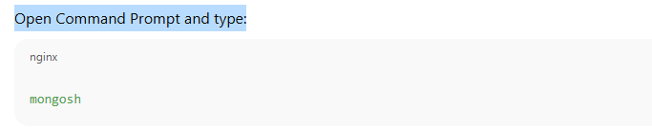
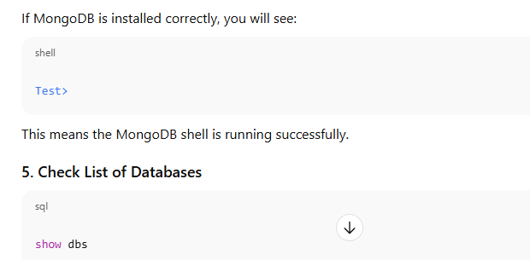

Conclusion:
The NoSQL lab demonstrates the use of MongoDB to store and manipulate semi-structured data. It shows that NoSQL databases provide flexibility, ease of scaling, and efficient handling of large datasets compared to traditional relational databases. MongoDB, a NoSQL database, was successfully installed and configured. Basic commands such as creating a database, inserting documents, and retrieving records were executed, demonstrating proper installation and functioning.

